Adventures In Berry Land

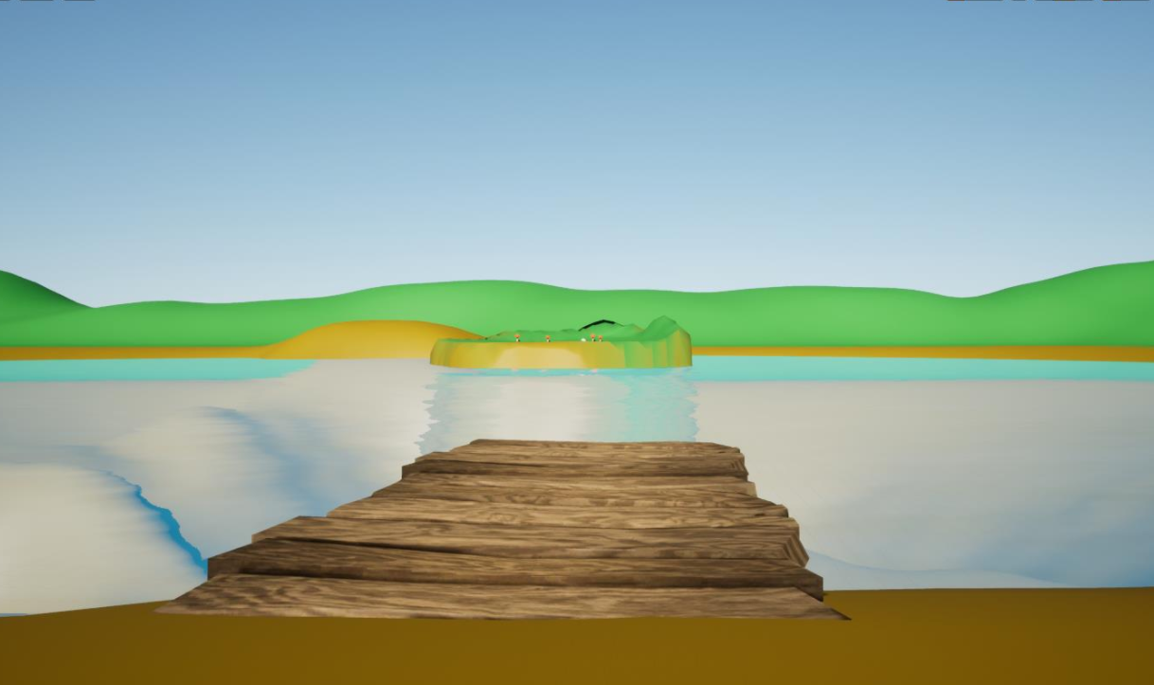

GAM537 – Midterm Project

Jennifer croft – 155901176

Patrick O’Reilly – 109646174

Table of Contents

Levels Page

Level 1 – **Berry Village** …………………………………………………………………………………………………. **3**

Village with lighting

Level 2 – **Fairy Forest** ……………………………………………………………………………………………………. **3**

Level 3 – **Finn Farm** ………………………………………………………………………………………………………. **4**

Level 4 – **Lucky Lake** ………….………………………………………………………………………………………… **4**

Boat Functionality ……………………………………………………………………………………………………….. **5**

Character and Animations Blueprints ………………………………………………………………………….. **6-9**

**LEVEL 1: Berry Village**

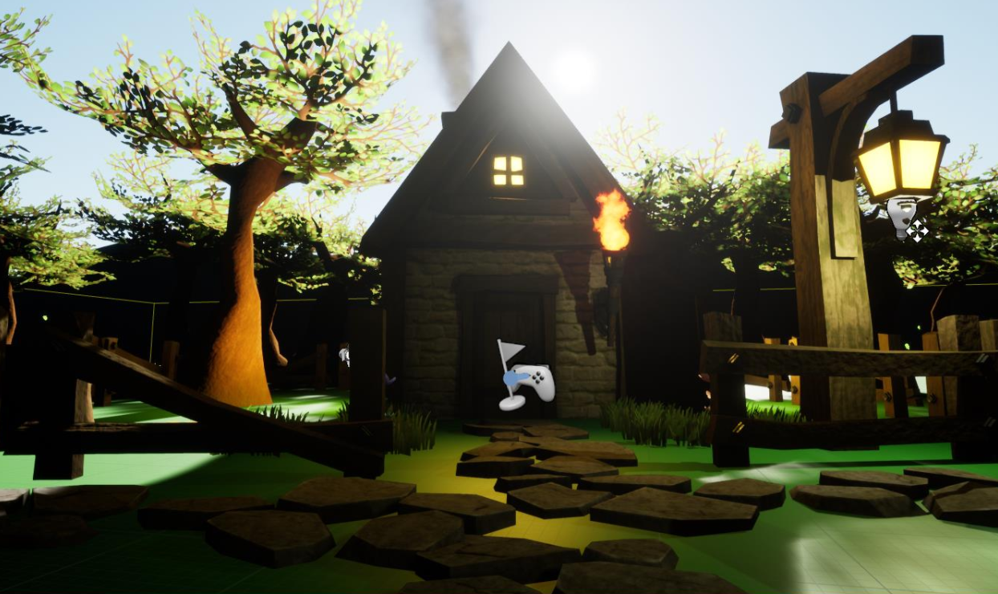

**LEVEL 2: Fairy Forest**

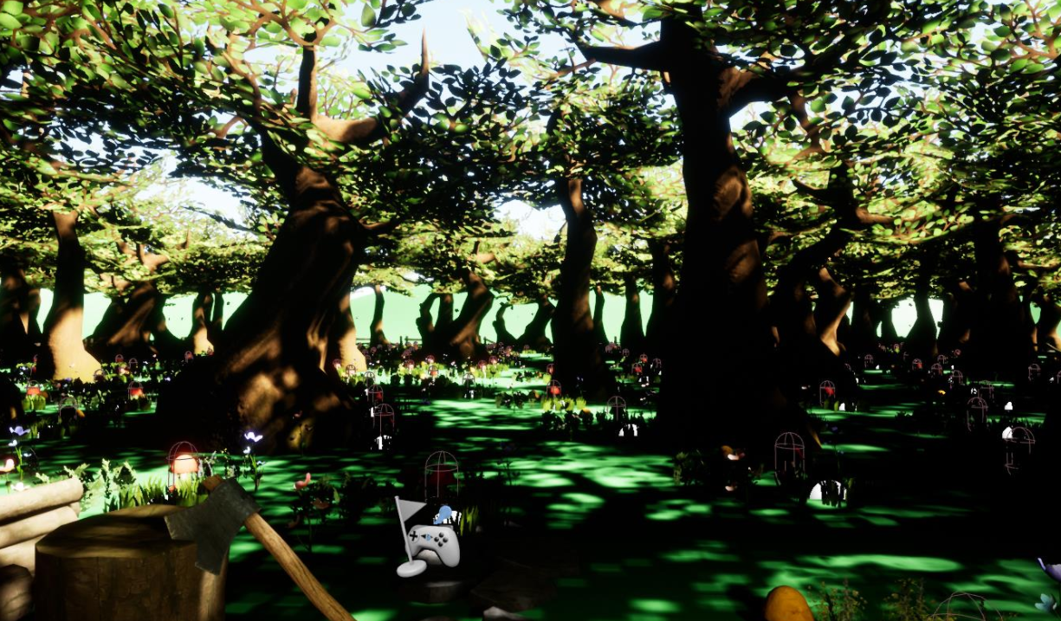

**LEVEL 3: Finn Farm**

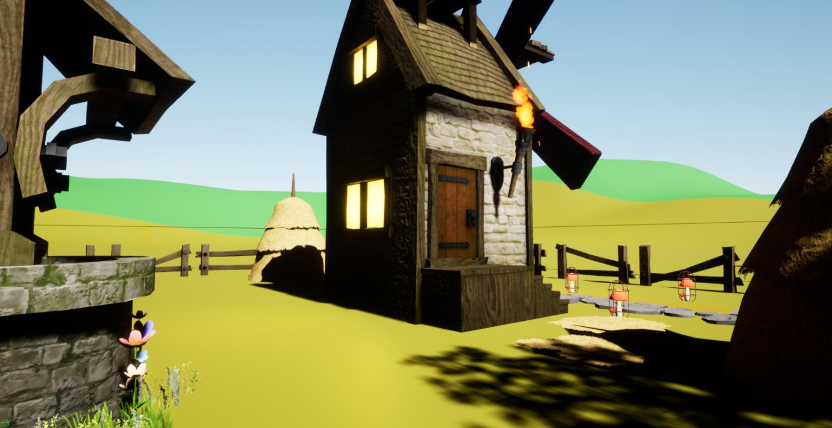

**LEVEL 4: Lucky Lake**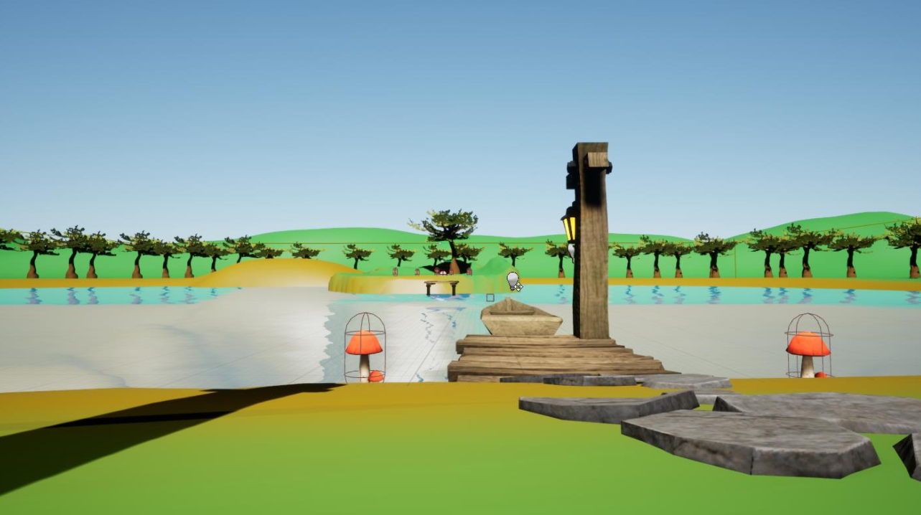

Lights and Effects – Water animation

The Boat – Moves to its endpoint with a timeline

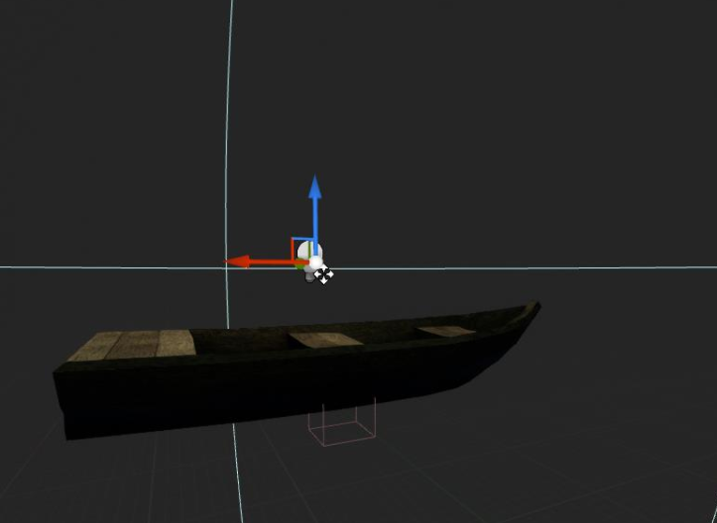

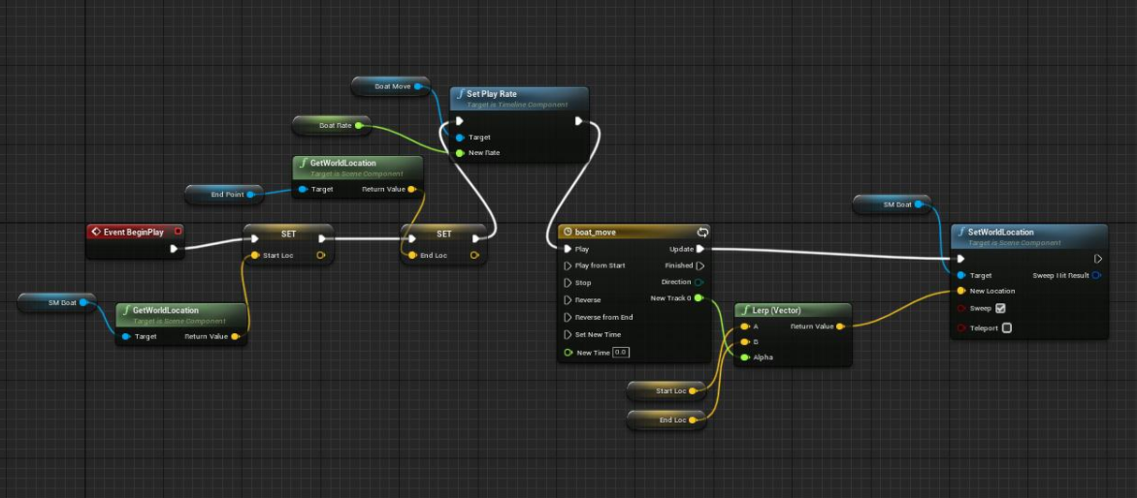

***Character and functionality***

Character Animation Graph - Speed and Jump

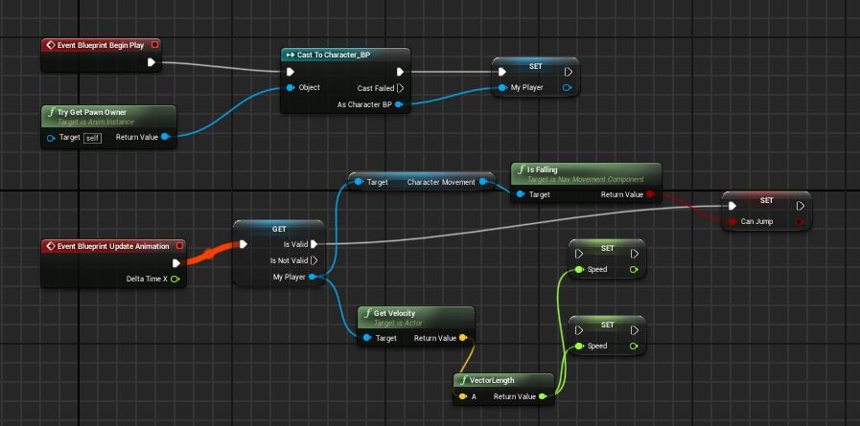

Walk Blueprints

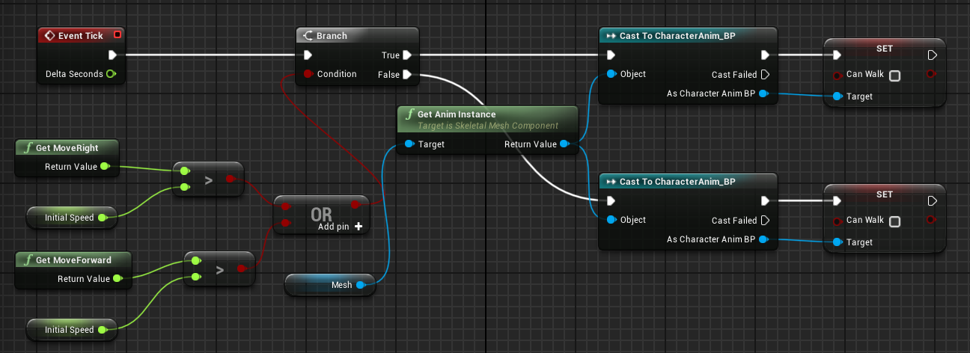

Rotation Control Blueprints

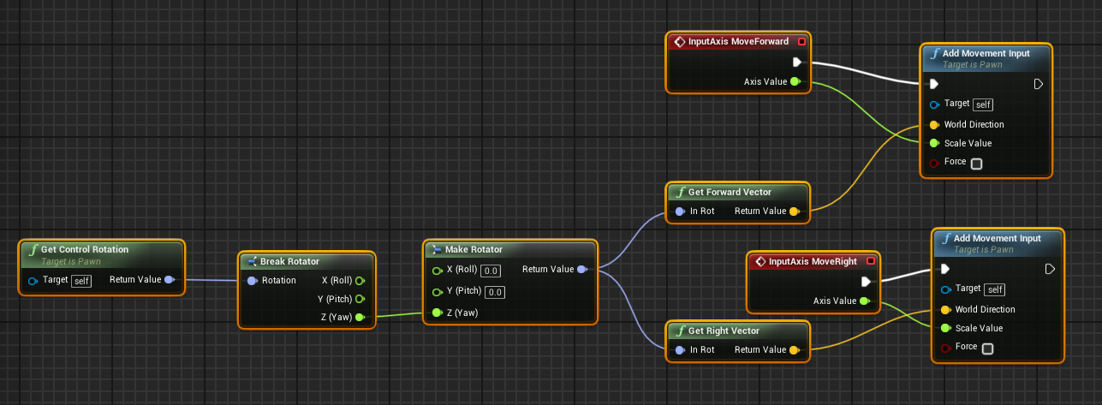

Health and Health Bar Blueprints

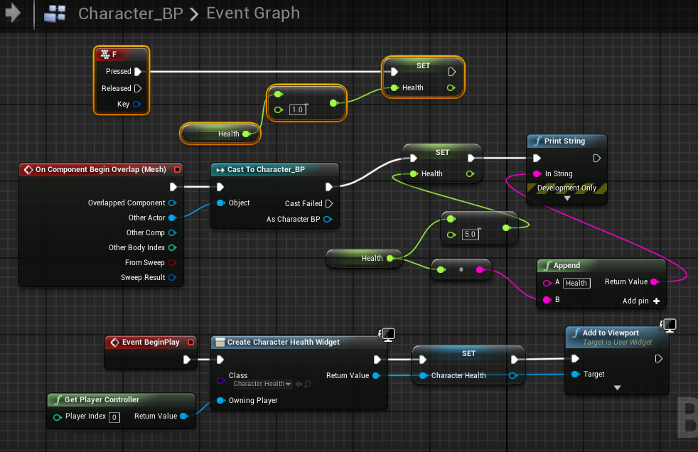

Death and Respawn Blueprints

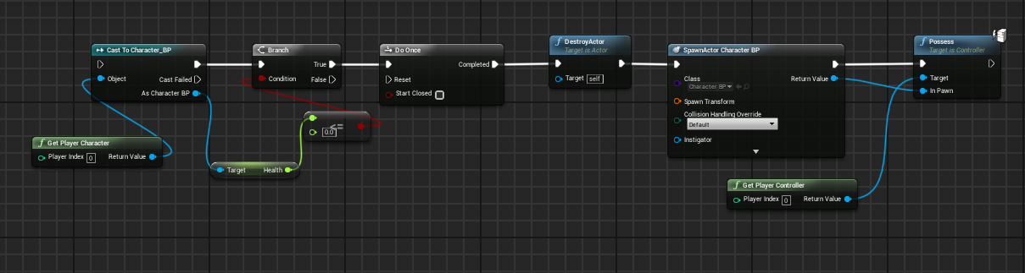

Pick-ups and Physics Handler Blueprints

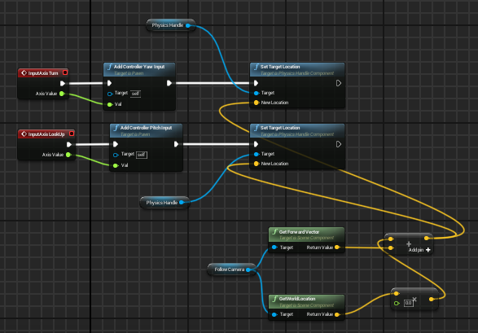

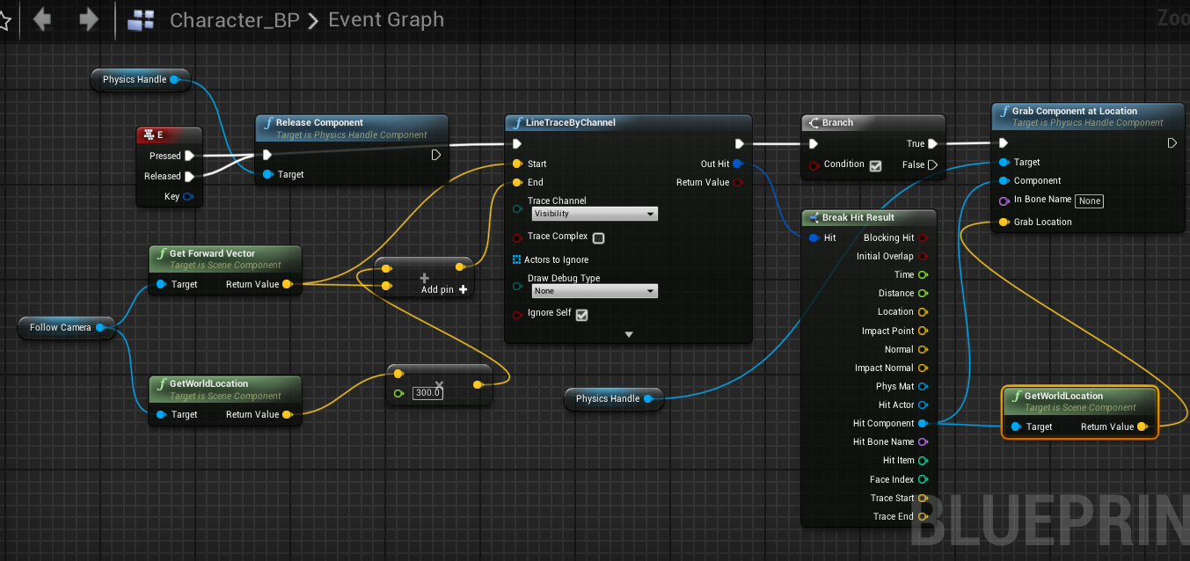

Box Trigger Blueprints

